BOARD OF TRUSTEES

CLOUD COUNTY COMMUNITY COLLEGE

January 29, 2013

MISSION

Cloud County Community College is dedicated to delivering high quality, innovative, affordable, and accessible educational opportunities and services that prepare a diverse population to be critical thinkers and lifelong learners who can meet the challenges of an ever-changing global community.

To assure the delivery of this mission, Cloud County Community College is directed by valid and reliable assessment techniques, which measure the effectiveness and efficiency of all departments in the delivery of curriculum and services in support of student academic success.

VISION

Cloud County Community College strives to enrich the lives of our students and the communities we serve.

CLOUD COUNTY COMMUNITY COLLEGE
BOARD OF TRUSTEES

AGENDA - January 29, 2013

Meeting Place: Room 257 in the President’s Addition
Time: 7:00 p.m.

- Call to Order – 7:00 p.m.

2. Adopt Agenda Decision

3. Guests’ Comments

4. Recognitions Information . Information

5. Program Highlights Information

6. President’s Message Information

7. Vice-President Reports Information

A. Vice President for Academic Affairs
B. Vice President for Administrative Services
C. Vice President for Enrollment Management and Student Services

8. Meeting Reports Information

9. Geary County Campus Update Information

10. Cloud County Community College Foundation Update Information

11. Approval of Minutes of December 18, 2012 and January 15, 2013 Decision

12. Finances Decision

A. Treasurer’s Report
B. Financial Overview

13. Purchasing and Payment of Claims Decision

14. Personnel Decision

- President’s Evaluation
- Head Volleyball Coach
- TRiO Student Support Services Project Facilitator Position
- Other

15. Facilities Decision

- Turbine Lowering
- Nordtank Blades
- Leak in Residence Life Building 9
- Other
CLOUD COUNTY COMMUNITY COLLEGE
BOARD OF TRUSTEES

Agenda - January 29, 2013

16. Academic Calendar Decision

17. President’s Travel Decision

18. Appoint Board Negotiating Team Decision

19. Information Items Information

- 2013 Telefund
- 33rd Annual Scholarship Auction
- Cook Series
- Phi Theta Kappa Academic All Americans
- NCK Community Band Concert
- “The Way We Worked” Exhibit
- Intergovernmental Meeting

20. Other

21. Executive Session Executive Session

A. Consultation with Legal Counsel
B. Non-elected Personnel
C. Negotiations

NEXT MEETING – February 26, 2012

CLOUD COUNTY COMMUNITY COLLEGE
BOARD OF TRUSTEES
January 29, 2013

ITEM NO: 1

AGENDA ITEM: Call to Order – 7:00 p.m.

ITEM TYPE:

COMMENT:

CLOUD COUNTY COMMUNITY COLLEGE
BOARD OF TRUSTEES
January 29, 2013

ITEM NO: 2

AGENDA ITEM: Adopt Agenda

ITEM TYPE: Decision

COMMENT:

Parliamentary rules recommend the adoption of the Agenda.

RECOMMENDED ACTION:

Adopt the Agenda for the January 29, 2013 Board of Trustees meeting.

CLOUD COUNTY COMMUNITY COLLEGE
BOARD OF TRUSTEES
January 29, 2013

ITEM NO: 3

AGENDA ITEM: Guests’ Comments

ITEM TYPE:

COMMENT:

CLOUD COUNTY COMMUNITY COLLEGE
BOARD OF TRUSTEES
January 29, 2013

ITEM NO: 4

AGENDA ITEM: Recognitions

ITEM TYPE: Information

COMMENT:

CLOUD COUNTY COMMUNITY COLLEGE
BOARD OF TRUSTEES
January 29, 2013

ITEM NO: 5

AGENDA ITEM: Program Highlights

ITEM TYPE: Information

COMMENT:

Michelle Charbonneau will share information about the Children’s Center.

CLOUD COUNTY COMMUNITY COLLEGE
BOARD OF TRUSTEES
January 29, 2013

ITEM NO: 6

AGENDA ITEM: President’s Message

ITEM TYPE: Information

COMMENT:

CLOUD COUNTY COMMUNITY COLLEGE
BOARD OF TRUSTEES
January 29, 2013

ITEM NO: 7

AGENDA ITEM: Vice President Reports

ITEM TYPE: Information

COMMENT:

- Vice President for Academic Affairs.

- Vice President for Administrative Services.

- Vice President for Enrollment Management and Student Services.

CLOUD COUNTY COMMUNITY COLLEGE
BOARD OF TRUSTEES
January 29, 2013

ITEM NO: 8

AGENDA ITEM: Meeting Reports

ITEM TYPE: Information

COMMENT:

CLOUD COUNTY COMMUNITY COLLEGE
BOARD OF TRUSTEES
January 29, 2013

ITEM NO: 9

AGENDA ITEM: Geary County Campus Update

ITEM TYPE: Information

COMMENT:

A monthly report from the Geary County Campus is enclosed.

Geary County Campus
Report to the Board of Trustees
January 29, 2013
This report highlights the recent activities of the offices of the Campus Dean, Student Services and Business and Industry Training:
Campus Activities – Brenda Edleston
- Tuesday, January 8, in-service was held for new adjunct faculty and adjunct faculty returning after a break in service. Eight attendees obtained information regarding operational procedures and use of the classroom technology.
- On two occasions in January, Brenda Edleston was interviewed by local reporters regarding the start of the Spring semester, Cloud County Community College’s presence in Geary County and the impact the College has on this area. One interview aired on KJCK radio. The second interview appeared in a print publication by the Daily Union.
- On Monday, January 21, Cathy Castle, Agri-Biotechnology instructor, and Brenda Edleston met with employees of New Horizons to continue training on the operation of the mobile lab.
- Cathy Castle and Brenda Edleston attended the Kansas Workforce Summit in Topeka January 23-24. The mobile lab was on display to promote the Agri-Biotechnology program as well as the TRAC-7 consortium.
Student Services Activities – Jennifer Zabokrtsky
Recruitment/Admissions/Scholarships
- Miriam Melendez, Student Services Specialist/Military Affairs Liaison, administered the Compass placement test to 31 prospective students December 11 – January 17.
- Jennifer Zabokrtsky, Coordinator of Student Services, and Amanda Rankin, Administrative Assistant for Business and Industry Programs, met with high school juniors and seniors at the Teen Center at Fort Riley. The purpose was to inform students about their options for taking classes while still enrolled in high school or after completing their high school educations. There were approximately 10 students in attendance, and two other schools (Barton and MATC) at the event.
- Military/Veterans
- Miriam Melendez reports an increase in the number of Geary County Campus students using Veteran’s Administration (VA) Benefits, as well as an increase in the number of military spouses using My Career Advancement Account (MyCAA) benefits.
- Currently, 79 students are receiving VA benefits on both campuses. All but seven of the current Geary County Campus students receiving VA benefits have completed their change form to switch their campus from Concordia to Geary County. New VA students continue to apply for benefits every week.
- Patti Elliott, Cloud’s Veteran’s Rep, was on campus Thursday, January 10, for Student Services Day, and Thursday, January 17, to assist Miriam Melendez in serving students receiving military benefits.
Enrollment/Advising/Transfer
- As of January 17, 445 students had enrolled on the Geary County Campus in 4,639 credit hours for the Spring 2013 semester. Since the last Board Report dated December 17, 2012, we have 175 students enrolled in 1,690 credit hours. We continued to enroll new students through Tuesday, January 22, the last day to add 16-week courses for the Spring semester.
- Student Services Day for the Spring 2013 semester was held on campus Thursday, January 10. Geary County Campus faculty and staff, as well as Patti Elliott, Assistant Registrar; Suzi Knoettgen, Director of Student Financial Aid; Joan Robison, Instructor and Advisor; Karen Leiszler, Accounts Receivable Specialist; Spencer Farha, Student Retention Specialist and Dave Merica, Information Technology Director, from the Concordia campus assisted students with enrollment, schedule changes, textbook orders, fee payment, financial aid, military benefits, placement testing and taking student ID photos. On Student Services Day, we enrolled 40 new students, completed 22 drop/adds, administered the Compass placement test to 13 new students and assisted 37 students with financial aid and/or military benefits questions.
- Spencer Farha was on campus Thursday, January 10, for Student Services Day and Thursday, January 17, to meet with students on Academic Probation.
- Brenda Hanson will be on campus Thursday, February 1, to meet with students regarding career assessment, internship placement, and career planning.
Other Activities
- New Student Orientation was held Monday, January 14. Fifty-seven new students, along with approximately 20 family members, attended four break-out sessions including Academics and Student Success, Student Services and i-Cloud, Student Organizations/Activities and the Student Success Center, in addition to meeting with Central National Bank and taking Student ID photos.
Business and Industry Training Programs – Jason York
- Approximately 15 students are scheduled to enroll in our January Phase I CDL course, which runs January 28 – 31. At least two students are taking the program as preparation for transfer to Manhattan Area Technical College for their Electrical Power and Distribution Program.
- CDL Phase II training (behind-the-wheel driving) is ongoing, and students are completing their driving examinations weekly at the Junction City DMV.
- In cooperation with JoDee Aldridge-Ball, Coordinator of Allied Health, twenty students took the CNA state board exam on Wednesday, January 9. Twenty-two students started CNA Online-Hybrid courses on January 7. The next CNA Online-Hybrid training begins February 4, and we will be enrolling at least 30 students for that start date with enrollment beginning January 25. The February Junction City CNA class has been reserved for students from Junction City High School who are enrolled in the high school’s medical program and earn concurrent credits. The next CNA state board exam for our students will be Wednesday, February 20, and we should have almost thirty students testing.
- The Spring 2013 EMT Course is scheduled for January 18 through May 15. Enrollment was held on January 9, with 12 students in attendance. There will be a second enrollment the night class starts. Four additional students are expected to attend that enrollment.
- The Region II SKEMS EMT Skills Exam has approved our request to host a regional exam again. The Skills Test will be held on the Geary County Campus on March 9.
- Currently, 11 students are enrolled in English as a Second Language (ESL) training.
- Jason York attended the Flint Hills Region Annual Leader’s Retreat for the Junction City, Manhattan and Wamego Chambers of Commerce held in Overland Park on January 18 and 19.
- On Tuesday, January 22, representatives from the Geary County Campus (including B&I, Student Services and the GCC Dean), attended the “1st Annual Next Generation Elective/Career Expo” at Manhattan High School. Approximately 2,500 students and community members attended throughout the day to discover new opportunities for education or training in the local area.

CLOUD COUNTY COMMUNITY COLLEGE
BOARD OF TRUSTEES
January 29, 2013

ITEM NO: 10

AGENDA ITEM: Cloud County Community College Foundation Update

ITEM TYPE: Information

COMMENT:

A report from the Cloud County Community College Foundation will be presented.

CLOUD COUNTY COMMUNITY COLLEGE
BOARD OF TRUSTEES
January 29, 2013

ITEM NO: 11

AGENDA ITEM: Approval of Minutes of December 18, 2012 and January 15, 2013

ITEM TYPE: Decision

COMMENT:

The minutes of the regular meeting of December 18, 2012 and the special meeting of
January 15, 2013 are enclosed.

RECOMMENDED ACTION:

Approve the minutes of December 18, 2012 and January 15, 2013.

CLOUD COUNTY COMMUNITY COLLEGE
BOARD OF TRUSTEES MEETING
December 18, 2012

Present: Ellen Anderson, Gregory Askren, David Clemons (by phone from 7:07 p.m. to 7:21 p.m.), Larry Henry, Roger Koester and Thomas Tuggle (arrived at 7:16 p.m.); President Danette Toone and Marilyn Martin, Clerk.

Others Present: Amy Hadachek, KNCK and Jessica LeDuc, Blade-Empire; Attorney Scott Condray, Shane Britt, Brenda Edleston, Joel Figgs, Kim Krull, Bob Maxson, David Merica, Kim Reynolds and Christine Wilson, staff.

Chairman Gregory Askren called the meeting to order at 7:00 p.m. in Room 257 of the President’s Addition.

David Clemons moved and Larry Henry seconded to adopt the agenda amended to switch Items 5 and 6; motion passed.

Guests’ Comments: None.

Recognitions: Kim Krull recognized Mitchel Stimers at the Geary County Campus for articles published on tornados.

Program Highlights: Kim Reynolds told the Board about the recruitment process.

Neil Phillips with Jared, Gilmore and Phillips, P.A., summarized the 2011-2012 audit. We received an unqualified audit. David Clemons moved and Larry Henry seconded to accept the 2011-2012 audit; motion passed. Bob Maxson recognized Mary LaBarge and Suzi Knoettgen for their hard work.

President’s Message: Dr. Toone reported the Foundation received a gift of $619,000 from an anonymous donor who wants others to know it’s important to fund this college. She and the Vice Presidents are working on a list of contributors who have used tax credits in support of the “Make Cook Grand” project.

Vice-Presidents’ Reports: Kim Krull, Vice President for Academic Affairs, reported faculty training has begun on the Learning Management System. The report requested by the Higher Learning Commission because of the article on on-line courses will be submitted on December 20. Approximately 300 man hours have been used by Community Education personnel for this report. An institutional researcher would have done this report. Bob Maxson, Vice President for Administrative Services, reported wellness activities are going to be held along with the in-service on January 11. The request for proposal for food service will be going out with the goal of bringing a recommendation to the Board in March. He has been working with the White Earth Tribal Council on the delivery of the Zond wind turbine. He is also working on the student account balances. Joel Figgs, Vice President for Enrollment Management and Student Services, reported his area has been busy with end of semester activities. Classes begin on January 15. A lot of Spring enrollment will occur between now and January 15.

Meeting Reports: David Clemons reported a special meeting of CloudCorp was held to accept the resignation of Kirk Lowell as Executive Director. Ashley McMillan has been appointed Interim Executive Director. The position will be advertised.

Geary County Campus Update: Brenda Edleston reported they are recruiting and enrolling students for the TRAC 7 grant programs and working on getting these courses on-line. The first field trip for the mobile lab is January 23-24 to Topeka for the Kansas Works Summit. A VA facility code for the Geary County Campus based on the cost of living in Junction City has been obtained. Staff is contacting the VA students to transfer their code from the Concordia code if appropriate. They could receive an additional $200 a month.

Cloud County Community College Foundation Update: Bob Maxson reported the Foundation Board elected officers for 2013. Tim Gottschalk was elected President, Mark Post Vice President and Shelly Farha Secretary. There are five director positions vacant on the Foundation Board. The Telefund is January 27 through February 12. The scholarship auction is April 27. Five applications have been received for the Executive Director position. They are readvertising in order to have a larger pool.

Roger Koester moved and Ellen Anderson seconded to approve the minutes of November 27, 2012; motion passed.

Roger Koester moved and Larry Henry seconded to approve the Treasurer’s Report as of November 30, 2012 with a cash balance of $3,977,504.26; motion passed.

Bob Maxson presented a financial overview. He said next month’s report will be one-half of the year. Auxiliaries continue to be strong. The move of extra grant money to the Fleet fund and the Turbine Repair fund will be reflected in the reports next month.

Roger Koester moved and Ellen Anderson seconded to approve the recommended room and board rates for academic year 2013-2014; motion passed 4-2 (Clemons and Tuggle voting no).

There were no expenditures or transfer of college funds of $10,000 or more on the (A) List.

The (B) List contained those checks/claims that had approval and/or met the requirements of state law. Ellen Anderson moved and David Clemons seconded to approve the (B) List; motion passed.

Roger Koester moved and David Clemons seconded to approve allowing Barbara Stevens to participate in the Early Retirement Program effective May 17, 2013 and authorize the administration to fill the Instructor in Art position vacancy; motion passed.

Consensus of the Board was to schedule the President’s Evaluation at a special meeting on Tuesday, January 15, 2013, at 7:00 a.m. in the President’s Office.

Chris Wilson explained the wellness opportunity scheduled for January 11.

Dr. Toone presented the Professional Development Plan.

Gregory Askren moved and Roger Koester seconded to accept the offer from White Earth Reservation Tribal Council for $90,000 for remaining Zond 750 kW turbine components and authorize the release of the security agreement with Heron Wind when that payment is received; motion passed.

Bob Maxson reported new mats will be put on the walls at the ends of Arley Bryant gymnasium. New wind powered lights have been put below the flagpole, and a new flag will be obtained.

Ellen Anderson moved and David Clemons seconded to approve Policy F27 Child Abuse; motion passed.

Information Items: The items were Student Services Days on both campuses, the first day of class on January 15, Youth for Music, induction into the Athletic Hall of Fame and Winter Homecoming, and the faculty/staff in-service on January 11.

Other: None.

Gregory Askren moved and David Clemons seconded to recess into executive session at 8:49 p.m. in Room 259 for discussion of non-elected personnel and return to regular session in Room 257 at 8:59 p.m. with the five Board members, Dr. Toone, Joel Figgs and Scott Condray present in the executive session; motion passed.

It was announced there would be no action taken following the executive session.

The meeting adjourned at 9:00 p.m.

______________________
Marilyn Martin, Clerk
Cloud County Community College
Board of Trustees

CLOUD COUNTY COMMUNITY COLLEGE
BOARD OF TRUSTEES SPECIAL MEETING
January 15, 2013

Present: Ellen Anderson, Gregory Askren, David Clemons, Larry Henry and Thomas Tuggle (by phone); President Danette Toone and Marilyn Martin, Clerk. Absent: Roger Koester.

Others Present: Chris Wilson.

Chairman David Clemons called the meeting to order at 7:00 a.m.

David Clemons moved and Larry Henry seconded to adopt the agenda; motion passed.

Ellen Anderson moved and David Clemons seconded to accept the resignation of Steve Ralos as Head Men’s and Women’s Soccer Coach effective January 15, 2013 and authorize the administration to fill the position vacancy; motion passed.

David Clemons moved and Ellen Anderson seconded to recess into executive session at 7:03 a.m. in the President’s Office for the evaluation of the President and return to regular session in the same place at 7:48 a.m. with the five Board members present in the executive session; motion passed.

David Clemons moved and Ellen Anderson seconded to recess into executive session at 7:50 a.m. in the President’s Office for the evaluation of the President and return to regular session in the same place at 8:20 a.m. with the five Board members present in the executive session; motion passed. Dr. Danette Toone entered the executive session at 8:05 a.m.

David Clemons moved and Ellen Anderson seconded to recess into executive session at 8:23 a.m. in the President’s Office for the evaluation of the President and return to regular session in the same place at 8:38 a.m. with the five Board members and Dr. Toone present in the executive session; motion passed

David Clemons moved and Ellen Anderson seconded to recess into executive session at 8:39 a.m. in the President’s Office for the evaluation of the President and return to regular session in the same place at 8:54 a.m. with the five Board members and Dr. Toone present in the executive session; motion passed.

The meeting adjourned at 8:55 a.m.

______________________
Marilyn A. Martin, Clerk
Cloud County Community College
Board of Trustees
CLOUD COUNTY COMMUNITY COLLEGE
BOARD OF TRUSTEES
January 29, 2013

ITEM NO: 12

AGENDA ITEM: Finances

ITEM TYPE: Decision

COMMENT:

A. Treasurer’s Report and Financial Report. These reports are enclosed.

RECOMMENDED ACTION: Approve the Treasurer’s Report as of
December 31, 2012 with a cash balance of $3,076,469.87.

B. Financial Overview. The financial overview of the College as of the end of December will be presented.

CLOUD COUNTY COMMUNITY COLLEGE
BOARD OF TRUSTEES
January 29, 2013

ITEM NO: 13

AGENDA ITEM: Purchasing and Payment of Claims

ITEM TYPE: Decision

COMMENT:

The purchase orders are enclosed or are available from the Clerk of the Board.

RECOMMENDED ACTION:

Approve the recommendations as stated.

CLOUD COUNTY COMMUNITY COLLEGE
BOARD OF TRUSTEES
January 29, 2013

(A) LIST
APPROVAL OF EXPENDITURES OR TRANSFERS OF COLLEGE FUNDS OVER $10,000.
This list contains requests for approval of expenditures or transfers of college funds over $10,000.
For some of the items listed, checks will be released prior to the next Board meeting and approval
of this list by the Board at this meeting will also authorize release of the checks. The other items,
orders will be prepared, and the payment of claims will be approved at the next Board meeting.

RECOMMENDED ACTION: Approve this list of expenditures or transfers of college funds over
$10,000.

- 01-83-9100-742 CENGAGE Learning Textbooks $ 16,547.86

- 01-83-9100-742 Nebraska Book Company Textbook 19,324.56

CLOUD COUNTY COMMUNITY COLLEGE
BOARD OF TRUSTEES
January 29, 2013

ITEM NO: 14

AGENDA ITEM: Personnel

ITEM TYPE: Decision

COMMENT:

A. President’s Evaluation.

B. Head Volleyball Coach. The search committee has been reviewing applications and interviewing candidates for this position. If available, a recommendation will be made for this position.

RECOMMENDED ACTION: Take action as appropriate.

C. TRiO Student Support Services Project Facilitator Position. Tara Shrake has a ten-month contract and the TRiO Administrative Assistant position is vacant. The Director of the TRiO Program, Dr. Krull and Dr. Toone recommend to not fill the administrative assistant position and make Tara Shrake’s contract a twelve-month contract to allow her to take on some of the administrative assistant duties. This is a grant-funded position.

RECOMMENDED ACTION: Approve changing the contract of Tara Shrake to the position of TRiO Student Support Services Project Facilitator on a twelve-month contract at the prorated salary of $32,900 retroactive to January 1, 2013.

- Other.

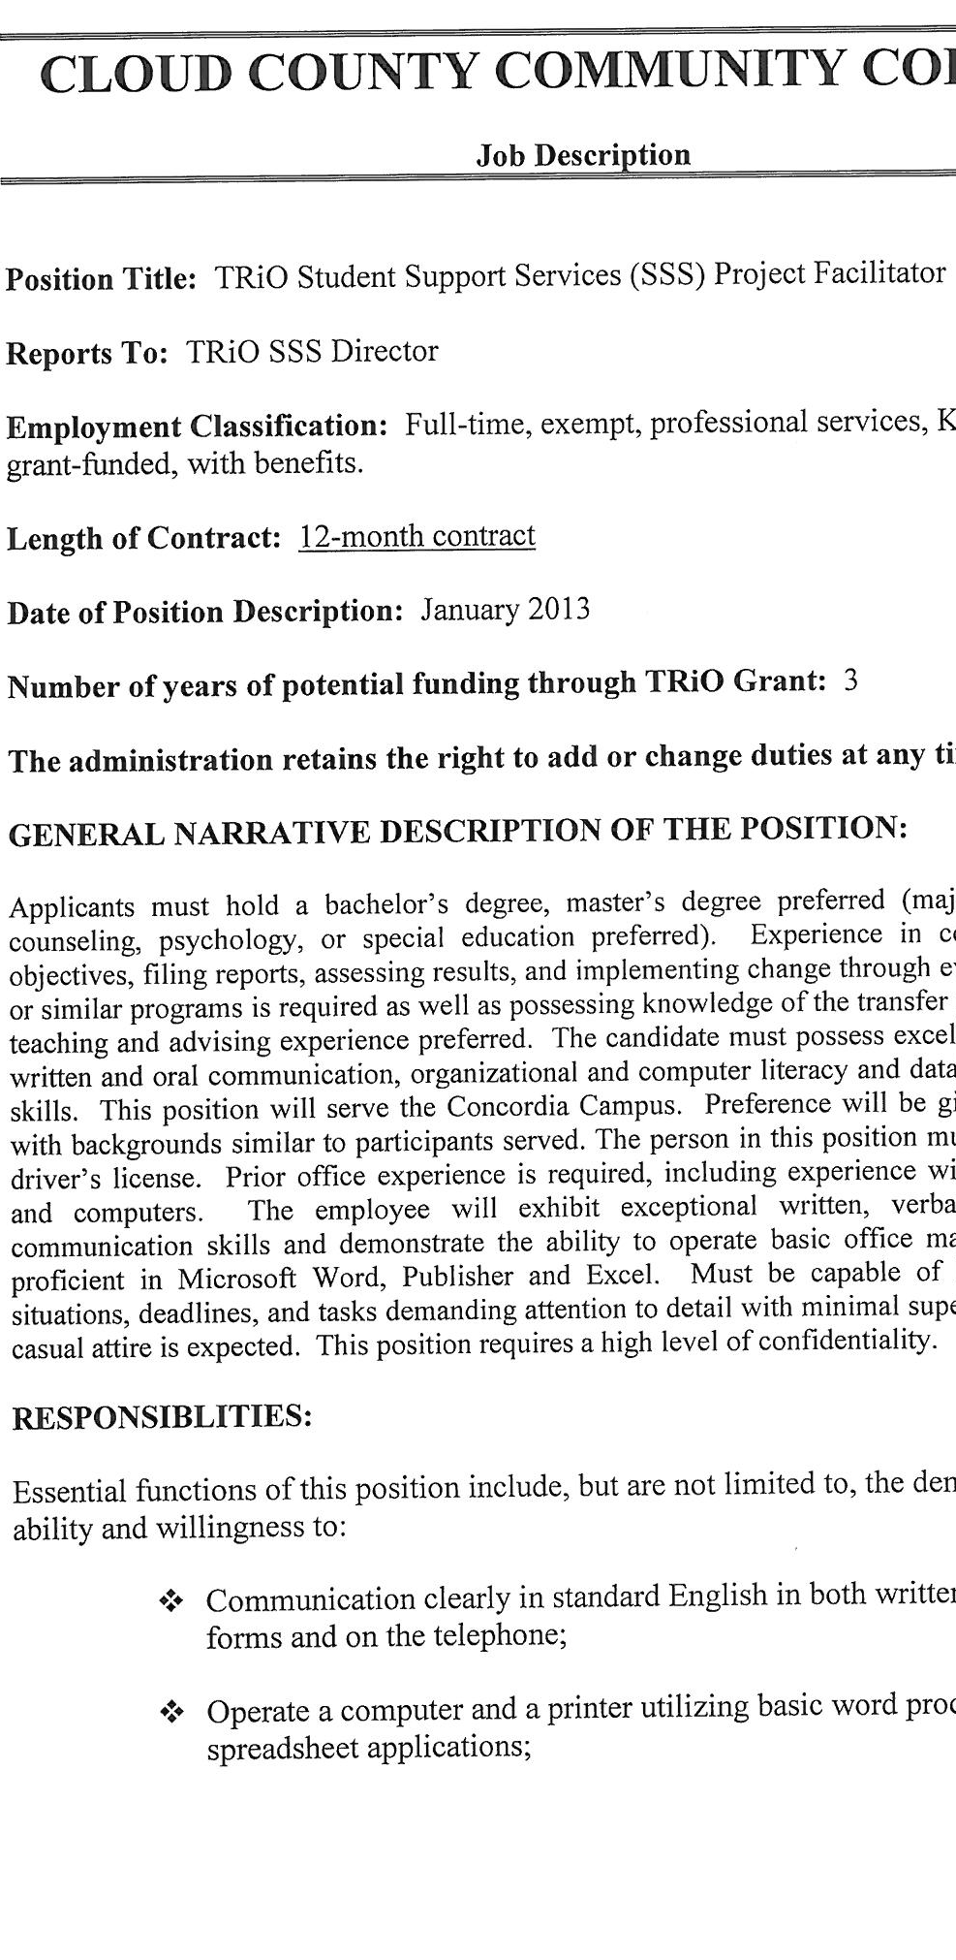

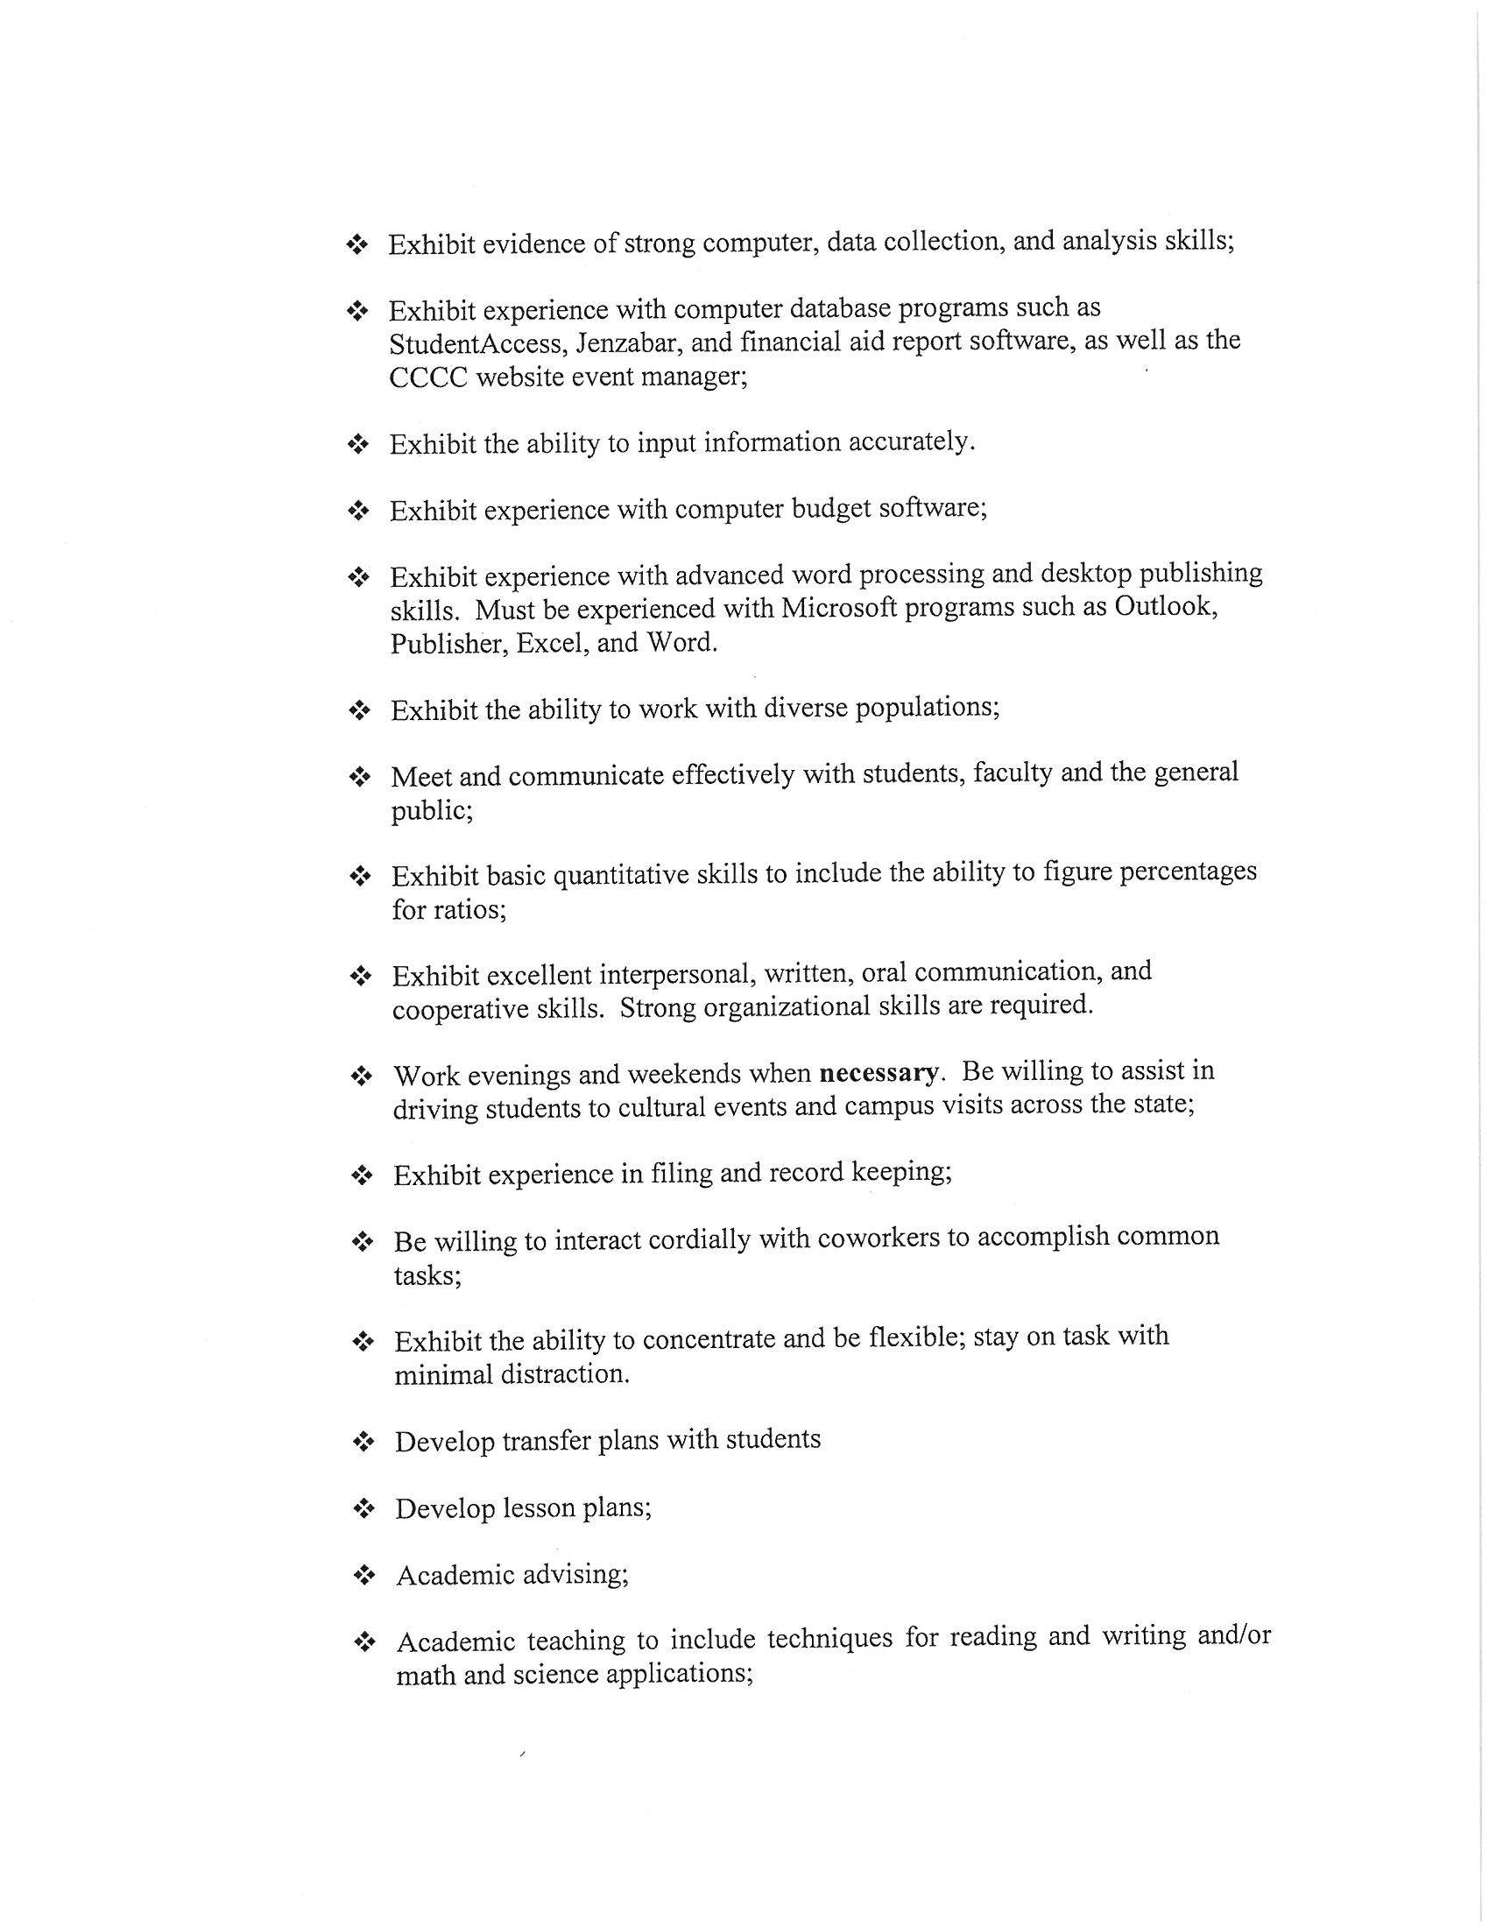

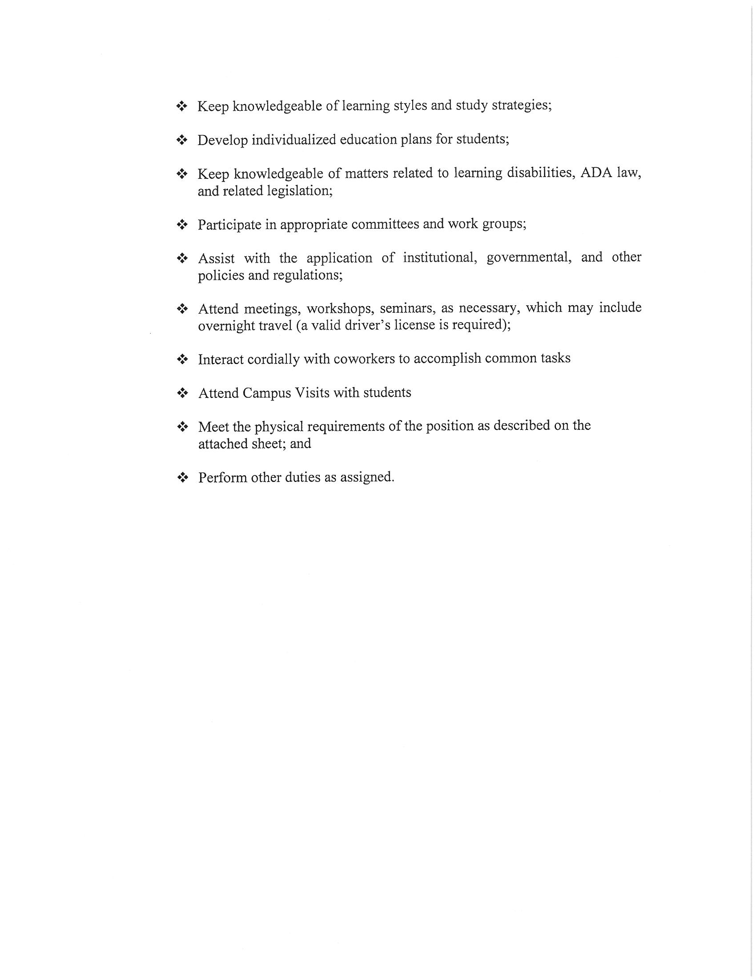

CLOUD COUNTY COMMUNITY COLLEGE
BOARD OF TRUSTEES
January 29, 2013

ITEM NO: 15

AGENDA ITEM: Facilities

ITEM TYPE: Decision

COMMENT:

- Turbine Lowering.

- Nordtank Turbine Blades.

- Leak in Residence Life Building 9.

D. Other.

CLOUD COUNTY COMMUNITY COLLEGE
BOARD OF TRUSTEES
January 29, 2013

ITEM NO: 16

AGENDA ITEM: Academic Calendar

ITEM TYPE: Decision

COMMENT:

Each year the staff recommends, the faculty reviews and the Board approves the Academic Calendar for the next year. The calendar will be brought to the meeting.

RECOMMENDED ACTION:
Approve the 2013-2014 Academic Calendar.

CLOUD COUNTY COMMUNITY COLLEGE
BOARD OF TRUSTEES
January 29, 2013

ITEM NO: 17

AGENDA ITEM: President’s Travel

ITEM TYPE: Decision

COMMENT:

President Toone is planning to attend the NCA HLC Annual Conference to be held in Chicago April 5-9, 2013. Policy C20 – President’s Travel requires pre-approval by the Board of Trustees on travel estimated to exceed $1,000. The estimated cost is as follows:

Registration $ 370.00
Hotel 750.00
Air fare 450.00
Meals 200.00
Taxi 60.00
$1,830.00

RECOMMENDED ACTION:
Approve the travel for Dr. Toone to Chicago, IL for the 2013 NCA HLC Annual Conference April 5-9, 2013.

CLOUD COUNTY COMMUNITY COLLEGE
BOARD OF TRUSTEES
January 29, 2013

ITEM NO: 18

AGENDA ITEM: Appoint Board Negotiating Team

ITEM TYPE: Decision

COMMENT:

The Board Chair needs to appoint two members and an alternate to the College Negotiating Team.

CLOUD COUNTY COMMUNITY COLLEGE
BOARD OF TRUSTEES
January 29, 2013

ITEM NO: 19

AGENDA ITEM: Information Items

ITEM TYPE: Information

COMMENT:

- 2013 Telefund. The 2013 Cloud County Community College Foundation Telefund began January 27, 2013.

- 33rd Annual Scholarship Auction. The 33rd Annual Scholarship Auction will be held Saturday, April 27, 2013, at the National Guard Armory. The silent auction begins at 5:30 p.m., dinner at 7:00 p.m. and the live auction at 8:00 p.m.

- Cook Series. Pippa White’s “One Woman Show” will be presented Sunday, February 10, 2013 at 2:00 p.m. in Cook Theatre. The Buster Keaton movie “Mont Alto” will be presented on Monday, February 25, 2013, at 7:30 p.m. in Cook Theatre.

D. Phi Theta Kappa Academic All Americans. The PTK Academic All-Americans will be honored in Topeka on February 14, 2013. The students from the Concordia Campus are Leah Hill and Dylan Hinrichs, and the students from the Geary County Campus are Cheryl Henderson and Noel Richardson.

E. NCK Community Band Concert. The NCK Community Band will be in concert with the Concordia High School Band on Thursday, February 14, 2013, at 7:00 p.m. in the Concordia High School Auditorium.

F. “The Way We Worked” Exhibit. This Smithsonian Exhibit will be on display at the National Orphan Train Complex February 2 to March 17, 2013.

CLOUD COUNTY COMMUNITY COLLEGE
BOARD OF TRUSTEES
January 29, 2013

ITEM NO: 19

AGENDA ITEM: Information Items (Cont’d)

ITEM TYPE: Information

COMMENT:

G. Intergovernmental Meeting. An intergovernmental meeting has been scheduled for Wednesday, February 20, 2013, at 7:00 p.m. at the St. Mary’s Parish Hall at 301 E. 1st in Glasco. Please let Marilyn know whether or not you plan to attend.

CLOUD COUNTY COMMUNITY COLLEGE
BOARD OF TRUSTEES
January 29, 2013

ITEM NO: 20

AGENDA ITEM: Other

ITEM TYPE:

COMMENT:

CLOUD COUNTY COMMUNITY COLLEGE
BOARD OF TRUSTEES
January 29, 2013

ITEM NO: 21

AGENDA ITEM: Executive Session

ITEM TYPE: Executive Session

COMMENT:

- Consultation with Legal Counsel.

- Non-elected Personnel.

- Negotiations.

