BOARD OF TRUSTEES

CLOUD COUNTY COMMUNITY COLLEGE

FEBRUARY 25, 2014

MISSION

Cloud County Community College is dedicated to delivering high quality, innovative, affordable, and accessible educational opportunities and services that prepare a diverse population to be critical thinkers and lifelong learners who can meet the challenges of an ever-changing global community.

To assure the delivery of this mission, Cloud County Community College is directed by valid and reliable assessment techniques, which measure the effectiveness and efficiency of all departments in the delivery of curriculum and services in support of student academic success.

VISION

Cloud County Community College strives to enrich the lives of our students and the communities we serve.

CLOUD COUNTY COMMUNITY COLLEGE
BOARD OF TRUSTEES

AGENDA - February 25, 2014

Meeting Place: Room 257 in the President’s Addition
Time: 6:00 p.m.

- Call to Order – 6:00 p.m.

2. Adopt Agenda Decision

3. Guests’ Comments

4. Recognitions Information . Information

5. Student Senate Information

- Concordia Campus
- Geary County Campus

6. Program Highlights Information

7. President’s Message Information

8. Vice-President Reports Information

A. Vice President for Academic Affairs
B. Vice President for Administrative Services
C. Vice President for Enrollment Management and Student Services

9. Meeting Reports Information

10. Geary County Campus Update Information

11. Cloud County Community College Foundation Update Information

12. Approval of Minutes of January 28, 2014 Decision

13. Finances Decision

A. Treasurer’s Report
B. Financial Overview
C. Scissor Lift Quotes

14. Purchasing and Payment of Claims Decision

15. Bids Decision

A. Main Building Roof Reconditioning Project

16. Personnel Decision

- Retirement – Karl de Rochefort-Reynolds
- Other
CLOUD COUNTY COMMUNITY COLLEGE
BOARD OF TRUSTEES

Agenda - February 25, 2014

17. Facilities

- Other
18. Information Items Information

- Cook Series
- High School Basketball and Volleyball All Star Weekend
- High School Regional Music Festival
- Junior Preview Day
- High School Art Show
- 34th Annual Scholarship Auction

19. Other Information

20. Executive Session Executive Session

A. Consultation with Legal Counsel
B. Non-elected Personnel
C. Negotiations

NEXT MEETING – March 25, 2014

CLOUD COUNTY COMMUNITY COLLEGE
BOARD OF TRUSTEES
February 25, 2014

ITEM NO: 1

AGENDA ITEM: Call to Order – 6:00 p.m.

ITEM TYPE:

COMMENT:

CLOUD COUNTY COMMUNITY COLLEGE
BOARD OF TRUSTEES
February 25, 2014

ITEM NO: 2

AGENDA ITEM: Adopt Agenda

ITEM TYPE: Decision

COMMENT:

Parliamentary rules recommend the adoption of the Agenda.

RECOMMENDED ACTION:

Adopt the Agenda for the February 25, 2014 Board of Trustees meeting.

CLOUD COUNTY COMMUNITY COLLEGE
BOARD OF TRUSTEES
February 25, 2014

ITEM NO: 3

AGENDA ITEM: Guests’ Comments

ITEM TYPE:

COMMENT:

CLOUD COUNTY COMMUNITY COLLEGE
BOARD OF TRUSTEES
February 25, 2014

ITEM NO: 4

AGENDA ITEM: Recognitions

ITEM TYPE: Information

COMMENT:

CLOUD COUNTY COMMUNITY COLLEGE
BOARD OF TRUSTEES
February 25, 2014

ITEM NO: 5

AGENDA ITEM: Student Senate

ITEM TYPE: Information

COMMENT:

- Concordia Campus.

- Geary County Campus.

CLOUD COUNTY COMMUNITY COLLEGE
BOARD OF TRUSTEES
February 25, 2014

ITEM NO: 6

AGENDA ITEM: Program Highlights

ITEM TYPE: Information

COMMENT:

Jamie Gross and Pat Damman will present activities in the Ag Department.

CLOUD COUNTY COMMUNITY COLLEGE
BOARD OF TRUSTEES
February 25, 2014

ITEM NO: 7

AGENDA ITEM: President’s Message

ITEM TYPE: Information

COMMENT:

CLOUD COUNTY COMMUNITY COLLEGE
BOARD OF TRUSTEES
February 25, 2014

ITEM NO: 8

AGENDA ITEM: Vice President Reports

ITEM TYPE: Information

COMMENT:

- Vice President for Academic Affairs.

- Vice President for Administrative Services.

- Vice President for Enrollment Management and Student Services.

CLOUD COUNTY COMMUNITY COLLEGE
BOARD OF TRUSTEES
February 25, 2014

ITEM NO: 9

AGENDA ITEM: Meeting Reports

ITEM TYPE: Information

COMMENT:

CLOUD COUNTY COMMUNITY COLLEGE
BOARD OF TRUSTEES
February 25, 2014

ITEM NO: 10

AGENDA ITEM: Geary County Campus Update

ITEM TYPE: Information

COMMENT:

A report from the Geary County Campus is enclosed.

Geary County Campus
Report to the Board of Trustees
February 25, 2014
This report highlights the recent activities of the offices of the Campus Dean, Student Services and Business and Industry:

Campus Activities – Brenda Edleston

- Cloud’s Agri-Biotechnology program has been in the news. This was the second year that Cloud displayed our mobile science laboratory at the Kansas Workforce Summit in Topeka. Both years Brenda Edleston was interviewed about the program. This link is to the 2013 interview with Farm Progress media group (Kansas Farmer). http://farmprogress.com/story-cloud-county-cc-takes-agri-biotechnology-road-14-95693. The article from the 2014 interview is attached.

- Last academic year, the College purchased through grant funds a software program called MathTutor. Over the course of the Fall 2013 semester, Geary County students logged a total of 36 hours and 21 minutes of volunteer time working with the math practice software. Of this time, 7 hours and 45 minutes were logged by students in our GED program.

- On February 10, Jason York, Laura MacLafferty and Brenda Edleston promoted Cloud’s technical programs at the Kansas Association for Career and Technical Education’s CTE Showcase at the Statehouse. The group had the opportunity to speak with legislators about the College’s current programs and possible future directions of reaching out to area high schools.

- The Student Senate sold Valentine gift bags and held a drawing for a ‘super Valentine’ gift collection. The money raised through this project will go toward the cost of the annual Spring Fling in April. The Senate’s goal is to cover the full cost of the Spring Fling and offer all of the day’s activities for free.

- The TRAC-7 program manager visited the Geary Campus on February 12 to review the progress of the grant efforts to date. Also that day a film crew shot still photographs and video of Agri-Biotechnology students working in the lab in Building D. These photographs and video will be used in outreach campaigns for television commercials. Radio ads are also being recorded to promote the College’s Agri-Biotechnology program.

- Dr. Pete Pellegrin, Brenda Edleston, and students Mary Smith and Tina Rollins attended the Phi Theta Kappa All-Kansas Academic Team honors luncheon in Topeka on February 13. Mrs. Smith and Mrs. Rollins were recognized for their outstanding academic and service accomplishments.

Student Services Activities – Jennifer Zabokrtsky

- Laura MacLafferty and Jennifer Zabokrtsky, Coordinator of Student Services, spoke with 20 prospective students at Flint Hills Job Corps in Manhattan on January 31 about Cloud County Community College, college admissions and financial aid.

- Laura MacLafferty is working with Patti Elliot and Jenny Acree to create a military education benefits page for Cloud’s web site.

- Second Start 8-week courses begin March 24.

- Student Services treated the students, faculty, and staff with “Sundaes on Thursday” on Feb. 13 to celebrate Valentine’s Day.

- Brenda Hanson was on campus January 30 and February 13 to assist students with career planning. Brenda also offered dining etiquette and interviewing skills workshops while she was on campus.

- Jennifer Zabokrtsky, Laura MacLafferty and Maria Fry (administrative assistant to Student Services) have worked diligently throughout the month to reach out to prospective students. All current students and the 164 prospective students who did not enroll in Spring 2014 classes were emailed news regarding the Second Start classes.

Business and Industry Training – Jason York

- Commercial Driver’s License Training and Motorcycle Safety Training will begin in March.

- We are currently working with Manhattan Area Technical College to schedule CDL training for twelve students who were late additions into the Electric Power Distribution Program. The students must complete the training and have their CDL license for summer internships.

- In cooperation with JoDee Aldridge-Ball:

  - Area healthcare industry professionals participated in an Allied Health Program Advisory Committee meeting and provided comments and suggestions for additional training topics and certificate programs in the healthcare industry.
  - Twenty students began CNA training on January 13.
  - Thirty students began CNA training on February 3.
  - Thirty seats will be available for CNA training beginning March 3 or March 10.
  - Eight students began EMT training for Spring 2014.
  - JoAnne Balthazor is working with a large health care entity to create an IV Therapy course on Cloud’s Geary County Campus.

- Eight students are enrolled in the evening welding course in Concordia. The course meets Thursday evenings throughout the semester at Concordia High School. We are very pleased to have Andy Massing as an instructor for the training.
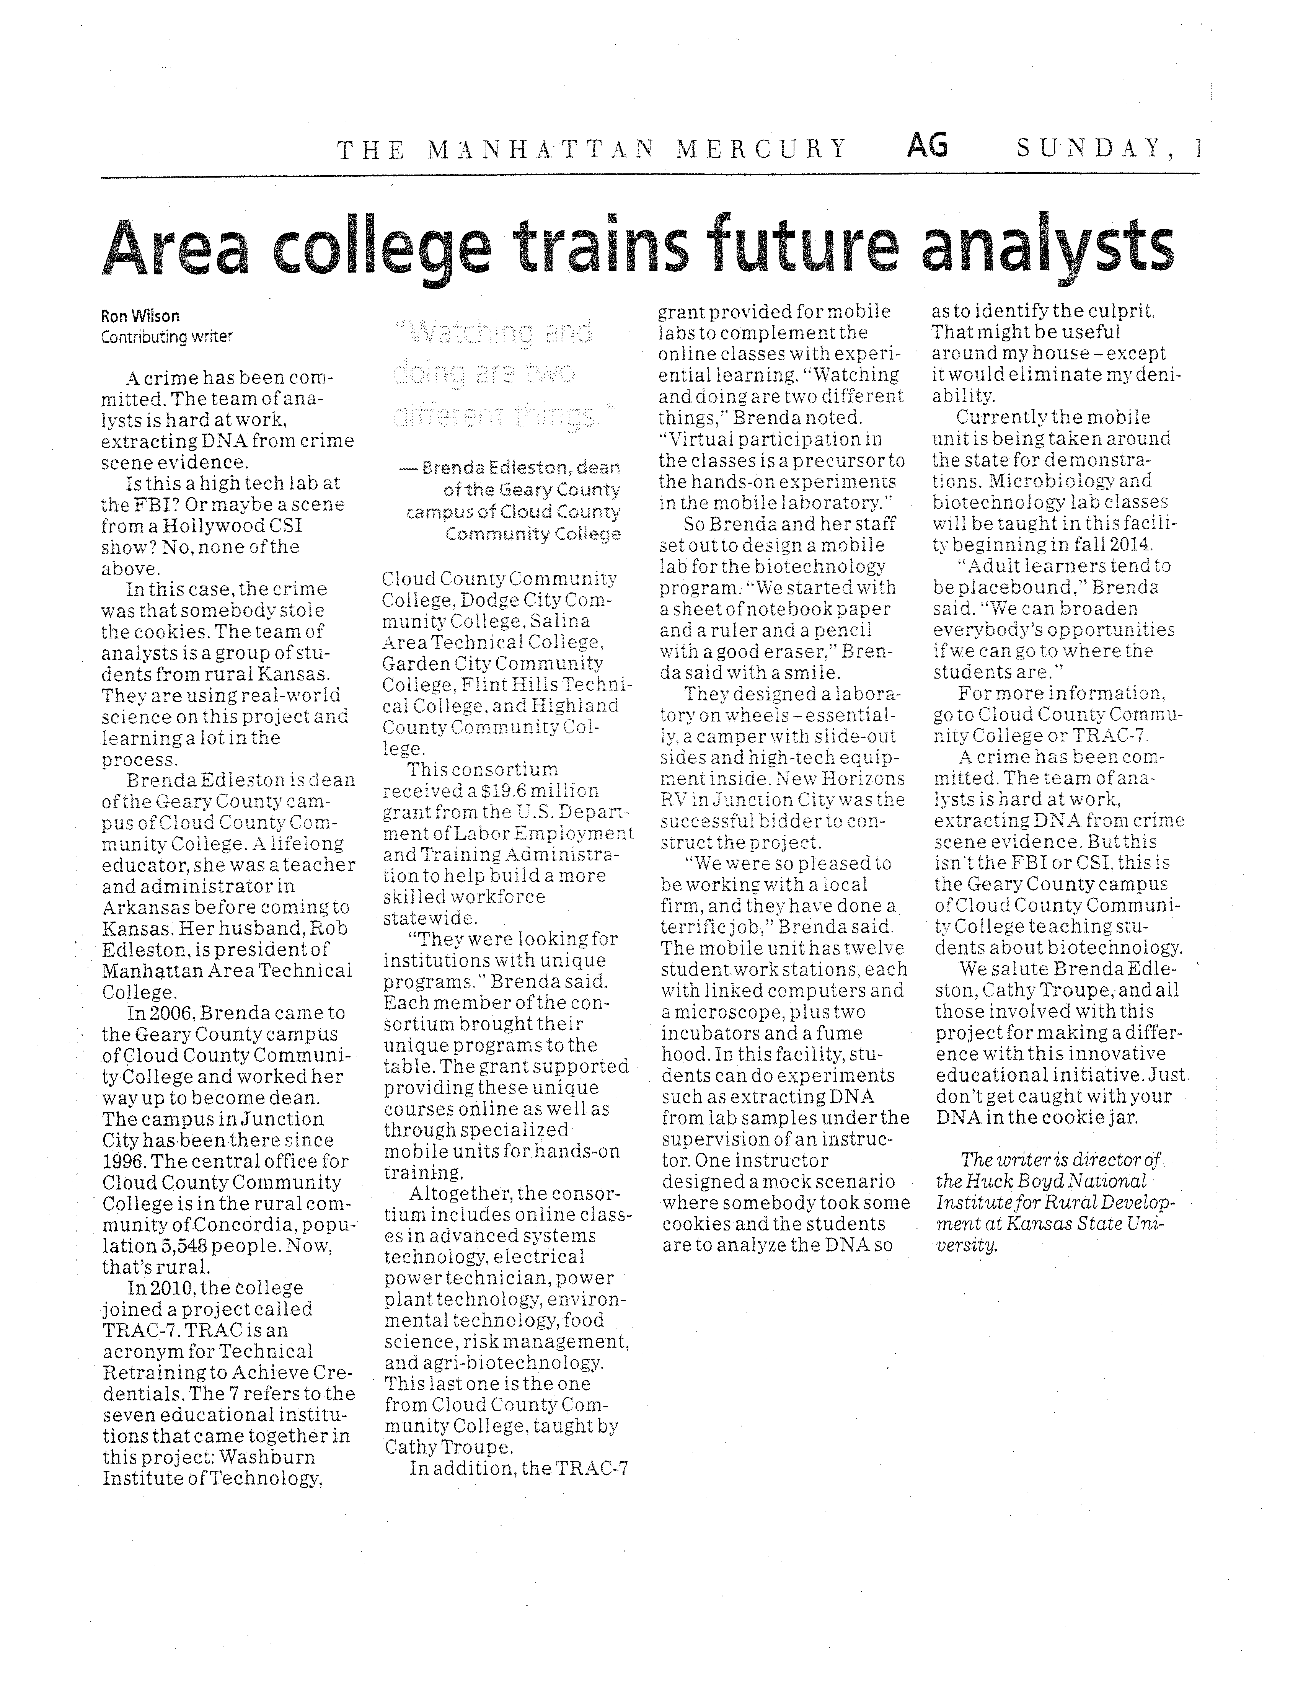

CLOUD COUNTY COMMUNITY COLLEGE
BOARD OF TRUSTEES
February 25, 2014

ITEM NO: 11

AGENDA ITEM: Cloud County Community College Foundation Update

ITEM TYPE: Information

COMMENT:

A report from the Cloud County Community College Foundation will be presented at the meeting.

CLOUD COUNTY COMMUNITY COLLEGE
BOARD OF TRUSTEES
February 25, 2014

ITEM NO: 12

AGENDA ITEM: Approval of Minutes of January 28, 2014

ITEM TYPE: Decision

COMMENT:

The minutes of the regular meeting of January 28, 2014 are enclosed.

RECOMMENDED ACTION:

Approve the minutes of January 28, 2014.

CLOUD COUNTY COMMUNITY COLLEGE
BOARD OF TRUSTEES
February 25, 2014

ITEM NO: 13

AGENDA ITEM: Finances

ITEM TYPE: Decision

COMMENT:

A. Treasurer’s Report and Financial Report. These reports are enclosed.

RECOMMENDED ACTION: Approve the Treasurer’s Report as of January 31, 2014 with cash balances of $7,925,864.75 at Central National Bank and $18,275.77 at Citizens National Bank.

B. Financial Overview. The financial overview of the College as of the end of January will be presented.

- Scissor Lift Quotes. Enclosed is a summary of three quotes for the purchase of a scissor lift for the Wind Energy program.

RECOMMENDED ACTION: Under Item 14, approve the A List which includes this item from Foley Equipment for $23,630.00.

Memorandum
T o: Board of Trustees
From: Robert P. Maxson, Vice President for Administrative Services
Danette Toone, President
Date: 2/20/2014

Subject: Recommendation on Purchase of Scissor Lift Based on Quotes

On the A List you will see a claim above $10,000 for the purchase of a 2013 Genie 3232 Scissor Lift from Foley Equipment, Concordia, KS for the Wind Energy program. On December 10, 2013, we requested and advertised for bids for the scissor lift. When we received bids for other requested items, we did not receive any bids for the scissor lift. College policy and procedures then call for us to seek quotes for the item. We have received three quotes for the specific item. The following is a list of quotes by vendors:
Vendor Location Quote
United Rentals Manhattan, KS $23,477.58
Foley Equipment Concordia, KS $23,630.00
Otay Messa Sales San Diego, CA $29,995.00

We recommend you approve the quote submitted by Foley Equipment, Concordia, KS for the purchase of the 2013 Genie 3232 Scissor Lift. Although this is $132.42 higher than the low bid, the difference in the quote is only 0.5% which is well below the Board of Trustees 5% level provided for in- county suppliers.
This purchase will be funded from U.S. Department of Energy funds and was budgeted in the grant for $23,319.00. The recommended price for the item is a bit higher than budgeted in the grant, but we have flexibility in changes in grant funds as needed to cover underestimates.

RECOMMENDED ACTION: Under Item 14, approve the A list which includes this item from Foley Equipment for $23,630.00

CLOUD COUNTY COMMUNITY COLLEGE
BOARD OF TRUSTEES
February 25, 2014

ITEM NO: 14

AGENDA ITEM: Purchasing and Payment of Claims

ITEM TYPE: Decision

COMMENT:

The purchase orders are enclosed or are available from the Clerk of the Board.

RECOMMENDED ACTION:

Approve the recommendations as stated.

CLOUD COUNTY COMMUNITY COLLEGE
BOARD OF TRUSTEES
February 25, 2014

(A) LIST
APPROVAL OF EXPENDITURES OR TRANSFERS OF COLLEGE FUNDS OVER $10,000.
This list contains requests for approval of expenditures or transfers of college funds over $10,000.
For some of the items listed, checks will be released prior to the next Board meeting and approval
of this list by the Board at this meeting will also authorize release of the checks. The other items,
orders will be prepared, and the payment of claims will be approved at the next Board meeting.

RECOMMENDED ACTION: Approve this list of expenditures or transfers of college funds over
$10,000.

1. 01-25-2007-852 Foley Equipment Scissor lift for Wind Energy $ 23,630.00
Program

CLOUD COUNTY COMMUNITY COLLEGE
BOARD OF TRUSTEES
February 25, 2014

ITEM NO: 15

AGENDA ITEM: Bids

ITEM TYPE: Decision

COMMENT:

- Main Building Roof Reconditioning Project. Bids for the Main Building Roof Reconditioning Project were solicited and opened February 21, 2014. A recommendation will be sent under separate cover.

RECOMMENDED ACTION: Take action as appropriate.

CLOUD COUNTY COMMUNITY COLLEGE
BOARD OF TRUSTEES
February 25, 2014

ITEM NO: 16

AGENDA ITEM: Personnel

ITEM TYPE: Decision

COMMENT:

- Retirement – Karl de Rochefort-Reynolds. Karl de Rochefort-Reynolds has submitted a letter of notification of his intent to participate in KPERS Retirement effective June 1, 2014, but continue to work as a full-time instructor until May 18, 2015. Mr. de Rochefort-Reynolds has been an employee of Cloud County Community College since August of 1987.

RECOMMENDED ACTION: Accept the notification of retirement from Karl de Rochefort-Reynolds to participate in KPERS retirement effective June 1, 2014, and his retirement from this full-time Instructor in Social Science position effective May 18, 2015 and authorize the administration to fill the position vacancy in 2015.

- Other.

CLOUD COUNTY COMMUNITY COLLEGE
BOARD OF TRUSTEES
February 25, 2014

ITEM NO: 17

AGENDA ITEM: Facilities

ITEM TYPE:

COMMENT:

- Other.

CLOUD COUNTY COMMUNITY COLLEGE
BOARD OF TRUSTEES
February 25, 2014

ITEM NO: 18

AGENDA ITEM: Information Items

ITEM TYPE: Information

COMMENT:

A. Cook Series. The Peterson Farm Boys will present “They Grow It” Thursday, March 27, at 7:00 p.m. in Cook Theatre.

B. High School Basketball and Volleyball All-Star Weekend. The High School Basketball and Volleyball All-Star Weekend will be Saturday and Sunday, March 29 and 30.

C. High School Regional Music Festival. The High School Regional Music Festival will be held at the College, Saturday, March 29.

- Junior Preview Day. Junior Preview Day will be Thursday, April 3. This is a time for High School Juniors to visit campus, explore majors and receive information on financial aid, housing and other areas.

- High School Art Show. The High School Art Show will be Friday, April 4, in Arley Bryant Gymnasium.

- 34th Annual Scholarship Auction. The 34th Annual Scholarship Auction will be held Saturday, April 5, at the Commercial Building at the Cloud County Fair Grounds. The silent auction begins at 5:30 p.m., dinner at 7:00 p.m. and the live auction at 8:00 p.m.

CLOUD COUNTY COMMUNITY COLLEGE
BOARD OF TRUSTEES
February 25, 2014

ITEM NO: 19

AGENDA ITEM: Other

ITEM TYPE:

COMMENT:

CLOUD COUNTY COMMUNITY COLLEGE
BOARD OF TRUSTEES
February 25, 2014

ITEM NO: 20

AGENDA ITEM: Executive Session

ITEM TYPE: Executive Session

COMMENT:

- Consultation with Legal Counsel.

- Non-elected Personnel

- Negotiations.

